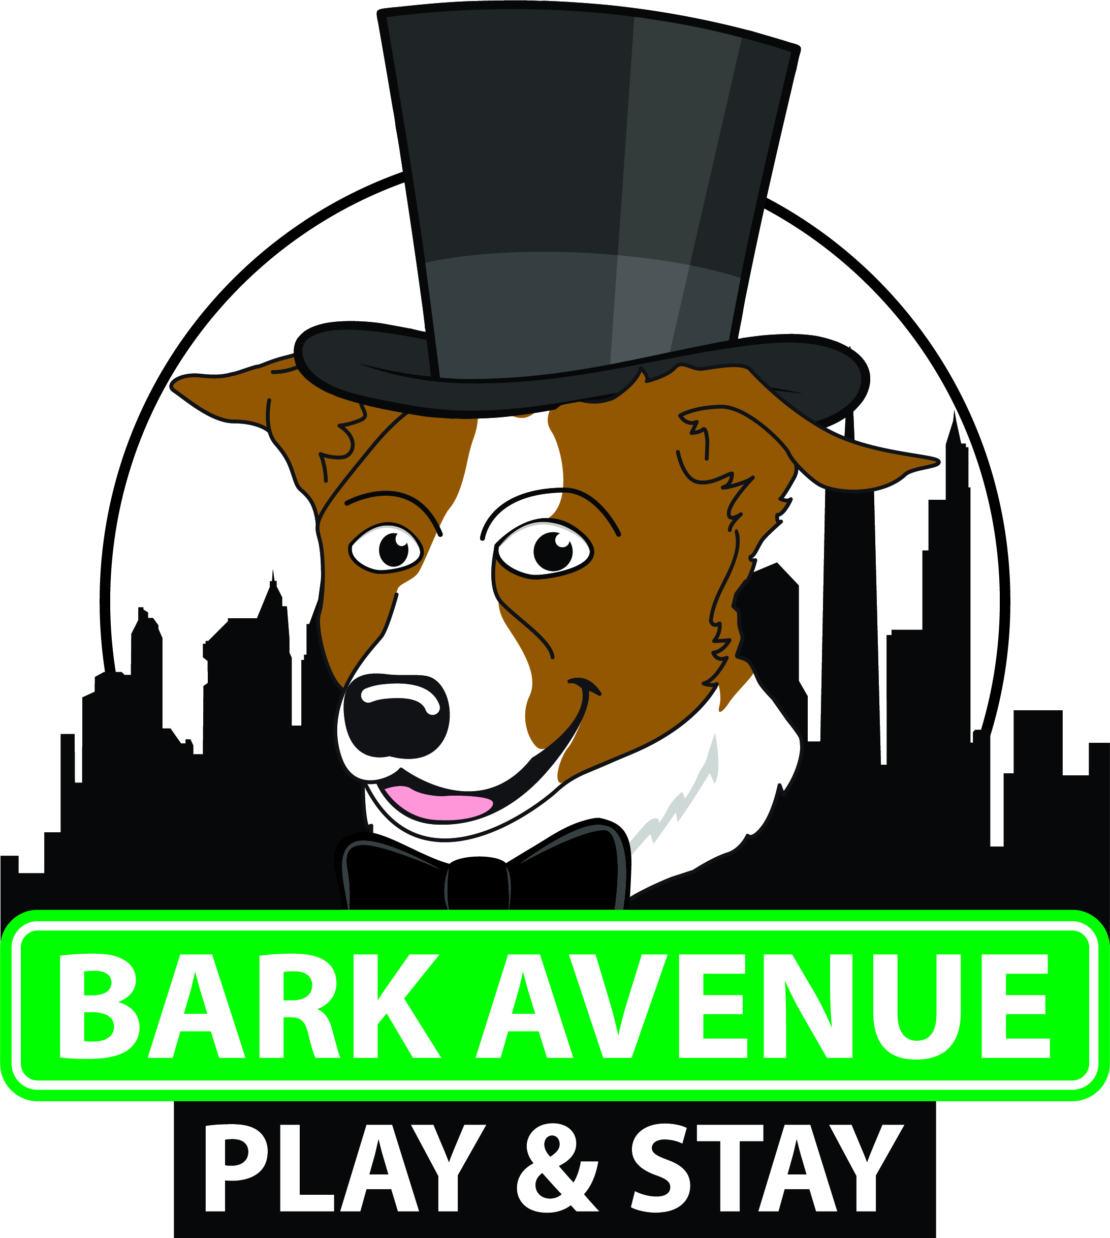

Application for Employment

Applicant Information
Applicant Name _____________________
Home Phone _______________________
Other ____________________________
Email Address _____________________
Current Address:
Number and street ____________________
City ________________________________
State & Zip ____________________________
How did you hear about Bark Avenue Play & Stay? _______________________________

Applying for: (mark those that apply)
__Dog Handler __Groomer __Trainer __Reception __Manager
Are you applying for:
- Temporary work – such as summer or holiday work? [ ] Y or [ ] N
- Regular part-time work? [ ] Y or [ ] N
- Regular full-time work? [ ] Y or [ ] N
If hired, on what date can you start working? ___ / ___ / ___
Can you work on the weekends? [ ] Y or [ ] N
Can you work evenings? [ ] Y or [ ] N
Salary desired: $________________________________

Days Available:

__Mon __Tu __W __Th __F __Sa __Su OR __ Flexible

Do You prefer: __Morning __Afternoon __Evening __Overnight

Personal Information & Job related requirements:
If hired, would you have transportation to/from work? [ ] Y or [ ] N
Are you over the age of 18? [ ] Y or [ ] N (if under 18, work permit is required if hired)
Can you stand on your feet, bend and lift for extended periods of time? [ ] Y or [ ] N
If hired, are you willing to submit to and pass a controlled substance test? [ ] Y or [ ] N
Have you ever been convicted of a felony? [ ] Y or [ ] N
Will you be able to purchase the required company uniforms? [ ] Y or [ ] N

Education:
High School:
School name: ________________________
School city, state, zip:________________________________
Number of years completed: _______________
Did you graduate? [ ] Y or [ ] N
Degree / diploma earned: _______________
College / University:
School name: __________________________
School city, state, zip:________________________________
Number of years completed: ________
Did you graduate? [ ] Y or [ ] N
Degree / diploma earned: __________________
Vocational School:
Name: ________________________
City, state, zip:________________________________
Number of years completed: ________
Did you graduate? [ ] Y or [ ] N
Degree / diploma? : __________________
Work Experience: (list last 4 employers, most current one first)
Employer #1
Name:_____________________________________________________
Address:___________________________________________________
Contact Name & Number:______________________________________
May we call? [ ] Y or [ ] N
Position & Job Duties:____________________________________________________
Reason for leaving:______________________________________________________
Employer #2
Name:_____________________________________________________
Address:___________________________________________________
Contact Name & Number:______________________________________
May we call? [ ] Y or [ ] N
Position & Job Duties:____________________________________________________
Reason for leaving:______________________________________________________
Employer #3
Name:_____________________________________________________
Address:___________________________________________________
Contact Name & Number:______________________________________
May we call? [ ] Y or [ ] N
Position & Job Duties:____________________________________________________
Reason for leaving:______________________________________________________
Employer #4
Name:_____________________________________________________
Address:___________________________________________________
Contact Name & Number:______________________________________
May we call? [ ] Y or [ ] N
Position & Job Duties:____________________________________________________
Reason for leaving:______________________________________________________
Animal Experience: (Please list any professional or volunteer animal experience you have had in the past. Example: Pet sitting, dog obedience classes, kennel work, etc.)_____________________________________________________________________________________________________________________________________________________________________________________________________________________________________________________________________________________________________________________________________________________________________________________________________________________________________
Why do you want to work with dogs?__________________________________________________________________________________________________________________________________________________________________________________________________________________________________________________________
References: (please list two references, one personal and one professional)
#1
Name:__________________________________________
Contact #:______________________________________
Relationship:____________________________________
Years Known:____________
#2
Name:_________________________________________
Contact #:_____________________________________
Relationship:__________________________________
Years Known:___________

I certify that the facts contained in this application are true to the best of my knowledge. If falsified statements are found in this application and hiring has occurred, this will be grounds for dismissal. I authorize Bark Avenue Play & Stay, LLC to conduct a full investigation of all statements contained in this application of references and employment history. I authorize Bark Avenue Play & Stay to conduct a full background check on me. I understand that if I am employed, either the employer or I may terminate the relationship at will, with or without cause, at any time, so long as there is no violation of federal or state law.

Applicant Signature: __________________________________________________________
Date: ______________________

